SIXTH SUNDAY OF EASTER
May 5, 2024

The Order for Worship

As We Gather
A treasured children’s song, “I Love to Tell the Story, has a refrain that follows each of the stanzas penned by poet Arabella Katherine Hankey, repeating the simple words: “I love to tell the story; ’Twill be my theme in glory, To tell the old, old story Of Jesus and His love.” The original Greek language in which John wrote his Gospel uses the word “love” either as a noun or a verb some nine times in the section of Jesus’ words heard in the Gospel for today. Jesus wants His disciples and us to know the abiding power of His love. It is that love that compels us to love one another—and the “others” beyond our circles of family, friends, and other close relationships. We are blessed in hearing the “old, old story of Jesus and His love” anew today. May we be blessed in telling it out in love as well!

Opening Proclamation (Psalm 118:24)
P "This is the day the Lord has made...
C We will rejoice and be glad in it."

Welcome & Announcements

Opening Hymn LSB 791 All People That on Earth Do Dwell
1 All people that on earth do dwell,
Sing to the Lord with cheerful voice.
Him serve with mirth, His praise forthtell;
Come ye before Him and rejoice.

2 Know that the Lord is God indeed;
Without our aid He did us make.
We are His folk, He doth us feed,
And for His sheep He doth us take.

3 O enter then His gates with praise;
Approach with joy His courts unto.
Praise, laud, and bless His name always,
For it is seemly so to do.

4 For why? The Lord our God is good:
His mercy is forever sure.
His truth at all times firmly stood
And shall from age to age endure.

D 5 To Father, Son, and Holy Ghost,
The God whom heav’n and earth adore,
From us and from the angel host
Be praise and glory evermore.
Text: William Kethe, d. c. 1593, alt.
Text: Public domain

The sign of the cross may be made by all in remembrance of their Baptism.

Invocation
P In the name of the Father and of the T Son and of the Holy Spirit.
C Amen.

Opening Sentences
P If we say we have no sin, we deceive ourselves, and the truth is not in us.
C But if we confess our sins, God, who is faithful and just, will forgive our sins and cleanse us from all unrighteousness.
Kneel/Stand

Silence for reflection on God’s Word and for self-examination.

Confession and Absolution
P Let us now confess our sin to God, our merciful Father.
C Gracious God, in heartfelt repentance we admit and confess our sinfulness. We are sin-stained people by nature. Each day we have sinned and done things we ought not to have done and have not done that which we are to have been doing as Your servants. We have not seen people in the loving way that You see them. We have not always been ready to care and quick to help. We do indeed deserve Your punishment in this life and for eternity. Trusting in Your mercy, we come to You for forgiveness. Our trust is in the merits of Your Son, our Savior, Jesus Christ. Have mercy on us, O God. Abide with us and grant us forgiveness of all our sins. By the power of the Holy Spirit at work within our hearts and lives, lead us into ways that reflect Your goodness and love.

P God is loving and merciful. He sees us with loving eyes and graciously hears our supplications. By the command of our Lord and as His called and ordained servant, I forgive you all of your sins in the name of the Father and of the T Son and of the Holy Spirit.
C Amen.

Kyrie 152
P In peace let us pray to the Lord.
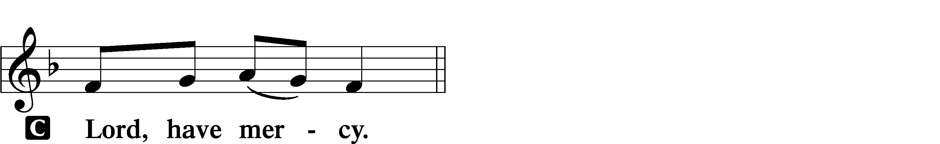

P For the peace from above and for our salvation let us pray to the Lord.
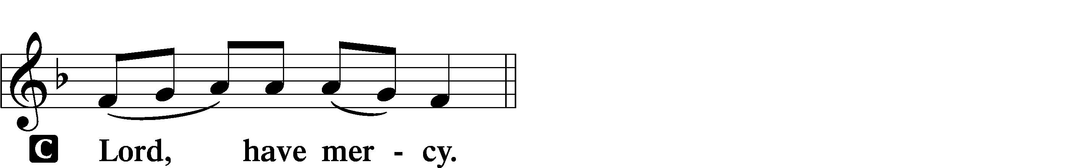

P For the peace of the whole world, for the well-being of the Church of God, and for the unity of all let us pray to the Lord.
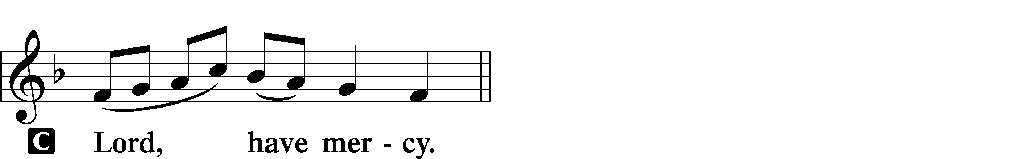

P For this holy house and for all who offer here their worship and praise let us pray to the Lord.
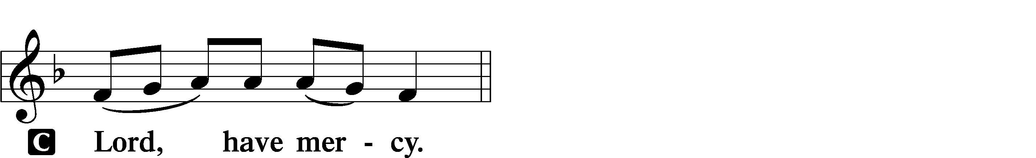

P Help, save, comfort, and defend us, gracious Lord.

This Is the Feast LSB 155
C This is the feast of victory for our God.
Alleluia, alleluia, alleluia.

Worthy is Christ, the Lamb who was slain, whose blood set us free to be people of God.

This is the feast of victory for our God.
Alleluia, alleluia, alleluia.

Power, riches, wisdom, and strength, and honor, blessing, and glory are His.

This is the feast of victory for our God.
Alleluia, alleluia, alleluia.

Sing with all the people of God, and join in the hymn of all creation:
Blessing, honor, glory, and might be to God and the Lamb forever. Amen.

This is the feast of victory for our God.
Alleluia, alleluia, alleluia.

For the Lamb who was slain has begun His reign. Alleluia.

This is the feast of victory for our God.
Alleluia, alleluia, alleluia.

Salutation and Collect of the Day
P The Lord be with you.
C And also with you.

P Let us pray.
O God, the giver of all that is good, by Your holy inspiration grant that we may think those things that are right and by Your merciful guiding accomplish them; through Jesus Christ, Your Son, our Lord, who lives and reigns with You and the Holy Spirit, one God, now and forever.

C Amen.

First Reading Acts 10:34–48
34Peter opened his mouth and said: “Truly I understand that God shows no partiality, 35but in every nation anyone who fears him and does what is right is acceptable to him. 36As for the word that he sent to Israel, preaching good news of peace through Jesus Christ (he is Lord of all), 37you yourselves know what happened throughout all Judea, beginning from Galilee after the baptism that John proclaimed: 38how God anointed Jesus of Nazareth with the Holy Spirit and with power. He went about doing good and healing all who were oppressed by the devil, for God was with him. 39And we are witnesses of all that he did both in the country of the Jews and in Jerusalem. They put him to death by hanging him on a tree, 40but God raised him on the third day and made him to appear, 41not to all the people but to us who had been chosen by God as witnesses, who ate and drank with him after he rose from the dead. 42And he commanded us to preach to the people and to testify that he is the one appointed by God to be judge of the living and the dead. 43To him all the prophets bear witness that everyone who believes in him receives forgiveness of sins through his name.”
44While Peter was still saying these things, the Holy Spirit fell on all who heard the word. 45And the believers from among the circumcised who had come with Peter were amazed, because the gift of the Holy Spirit was poured out even on the Gentiles. 46For they were hearing them speaking in tongues and extolling God. Then Peter declared, 47“Can anyone withhold water for baptizing these people, who have received the Holy Spirit just as we have?” 48And he commanded them to be baptized in the name of Jesus Christ. Then they asked him to remain for some days.

A This is the Word of the Lord.
C Thanks be to God.

Psalm 98:1-9
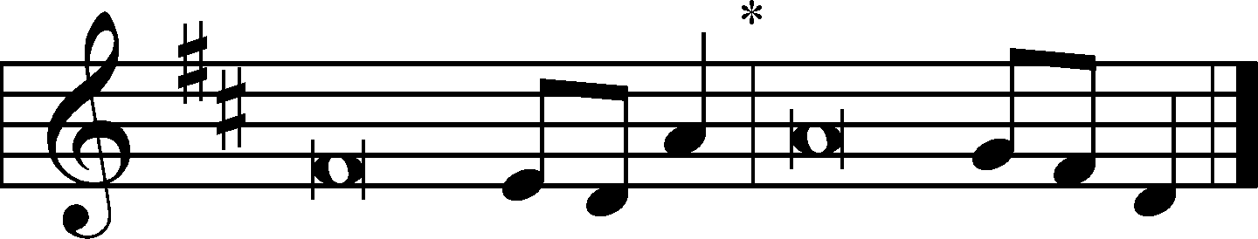
1Oh sing to the Lord a new song,
for he has done | marvelous things!*
His right hand and his holy arm
have worked salva- | tion for him.
2The Lord has made known his sal- | vation;*
he has revealed his righteousness in the sight of the | nations.
3He has remembered his steadfast love and faithfulness
to the house of | Israel.*
All the ends of the earth have seen
the salvation | of our God.
4Make a joyful noise to the Lord, | all the earth;*
break forth into joyous song and sing | praises!
5Sing praises to the Lord | with the lyre,*
with the lyre and the sound of | melody!
6With trumpets and the sound | of the horn*
make a joyful noise before the | King, the Lord!
7Let the sea roar, and all that | fills it;*
the world and those who | dwell in it!
8Let the rivers clap their hands;
let the hills sing for joy together
9be- | fore the Lord,* for he comes
to | judge the earth.
He will judge the world with | righteousness,*
and the peoples with | equity.

Epistle Reading 1 John 5:1–8
1Everyone who believes that Jesus is the Christ has been born of God, and everyone who loves the Father loves whoever has been born of him. 2By this we know that we love the children of God, when we love God and obey his commandments. 3For this is the love of God, that we keep his commandments. And his commandments are not burdensome. 4For everyone who has been born of God overcomes the world. And this is the victory that has overcome the world—our faith. 5Who is it that overcomes the world except the one who believes that Jesus is the Son of God?
6This is he who came by water and blood—Jesus Christ; not by the water only but by the water and the blood. And the Spirit is the one who testifies, because the Spirit is the truth. 7For there are three that testify: 8the Spirit and the water and the blood; and these three agree.

A This is the Word of the Lord.
C Thanks be to God.

Alleluia and Verse LSB 156
C Alleluia.
Lord, to whom shall we go?
You have the words of eternal life.
Alleluia, alleluia.

Holy Gospel Reading John 15:9–17
P The Holy Gospel according to St. John, the fifteenth chapter.
C Glory to You, O Lord.

9[Jesus said:] “As the Father has loved me, so have I loved you. Abide in my love. 10If you keep my commandments, you will abide in my love, just as I have kept my Father’s commandments and abide in his love. 11These things I have spoken to you, that my joy may be in you, and that your joy may be full.
12“This is my commandment, that you love one another as I have loved you. 13Greater love has no one than this, that someone lays down his life for his friends. 14You are my friends if you do what I command you. 15No longer do I call you servants, for the servant does not know what his master is doing; but I have called you friends, for all that I have heard from my Father I have made known to you. 16You did not choose me, but I chose you and appointed you that you should go and bear fruit and that your fruit should abide, so that whatever you ask the Father in my name, he may give it to you. 17These things I command you, so that you will love one another.”

P This is the Gospel of the Lord.
C Praise to You, O Christ.

Creed
P The First Reading today tells how the gift of the Holy Spirit was given to Gentiles as well as to Jews—which includes all the peoples of the world. Sharing words of faith confessed around the world, we speak together the words of the Apostles’ Creed regarding the Third Person of the Holy Trinity and then express our confession of its meaning in the Small Catechism words of Martin Luther.
C I believe in the Holy Spirit, the holy Christian Church, the communion of saints, the forgiveness of sins, the resurrection of the body, and the life everlasting. Amen.

P What does this mean?
C I believe that I cannot by my own reason or strength believe in Jesus Christ, my Lord, or come to Him; but the Holy Spirit has called me by the Gospel, enlightened me with His gifts, sanctified and kept me in the true faith.
In the same way He calls, gathers, enlightens, and sanctifies the whole Christian Church on earth, and keeps it with Jesus Christ in the one true faith.
In this Christian Church He daily and richly forgives all my sins and the sins of all believers.
On the Last Day He will raise me and all the dead, and give eternal life to me and all believers in Christ.
This is most certainly true.

Hymn of Praise LSB 700 Love Divine, All Loves Excelling
1 Love divine, all loves excelling,
Joy of heav’n, to earth come down!
Fix in us Thy humble dwelling,
All Thy faithful mercies crown.
Jesus, Thou art all compassion,
Pure, unbounded love Thou art;
Visit us with Thy salvation,
Enter ev’ry trembling heart.

2 Breathe, O breathe Thy loving Spirit
Into ev’ry troubled breast;
Let us all in Thee inherit;
Let us find Thy promised rest.
Take away the love of sinning;
Alpha and Omega be;
End of faith, as its beginning,
Set our hearts at liberty.

3 Come, Almighty, to deliver;
Let us all Thy life receive;
Suddenly return, and never,
Nevermore Thy temples leave.
Thee we would be always blessing,
Serve Thee as Thy hosts above,
Pray and praise Thee without ceasing,
Glory in Thy perfect love.

4 Finish then Thy new creation,
Pure and spotless let us be;
Let us see Thy great salvation
Perfectly restored in Thee,
Changed from glory into glory,
Till in heav’n we take our place,
Till we cast our crowns before Thee,
Lost in wonder, love, and praise!
Text: Charles Wesley, 1707–88
Text: Public domain

Sermon

Offertory LSB 159
C What shall I render to the Lord for all His benefits to me?
I will offer the sacrifice of thanksgiving and will call on the name of the Lord.
I will take the cup of salvation and will call on the name of the Lord.
I will pay my vows to the Lord now in the presence of all His people,
in the courts of the Lord’s house, in the midst of you, O Jerusalem.

Offering

New Member Reception

Prayer of the Church

Lord’s Prayer LSB 162
P Lord, remember us in Your kingdom and teach us to pray:
C Our Father who art in heaven,
hallowed be Thy name,
Thy kingdom come,
Thy will be done on earth
as it is in heaven;
give us this day our daily bread;
and forgive us our trespasses
as we forgive those
who trespass against us;
and lead us not into temptation,
but deliver us from evil.
For Thine is the kingdom
and the power and the glory
forever and ever. Amen.

The Words of Our Lord

Pax Domini LSB 163
P The peace of the Lord be with you always.
C Amen.

Agnus Dei LSB 163
C Lamb of God, You take away the sin of the world; have mercy on us.
Lamb of God, You take away the sin of the world; have mercy on us.
Lamb of God, You take away the sin of the world; grant us peace.

Distribution Hymn LSB 556 Dear Christians, One and All, Rejoice sts. 1–2, 4–5, 7, 10
1 Dear Christians, one and all, rejoice,
With exultation springing,
And with united heart and voice
And holy rapture singing,
Proclaim the wonders God has done,
How His right arm the vict’ry won.
What price our ransom cost Him!

2 Fast bound in Satan’s chains I lay;
Death brooded darkly o’er me.
Sin was my torment night and day;
In sin my mother bore me.
But daily deeper still I fell;
My life became a living hell,
So firmly sin possessed me.

4 But God had seen my wretched state
Before the world’s foundation,
And mindful of His mercies great,
He planned for my salvation.
He turned to me a father’s heart;
He did not choose the easy part
But gave His dearest treasure.

5 God said to His belovèd Son:
“It’s time to have compassion.
Then go, bright jewel of My crown,
And bring to all salvation.
From sin and sorrow set them free;
Slay bitter death for them that they
May live with You forever.”

7 To me He said: “Stay close to Me,
I am your rock and castle.
Your ransom I Myself will be;
For you I strive and wrestle.
For I am yours, and you are Mine,
And where I am you may remain;
The foe shall not divide us.

10 “What I on earth have done and taught
Guide all your life and teaching;
So shall the kingdom’s work be wrought
And honored in your preaching.
But watch lest foes with base alloy
The heav’nly treasure should destroy;
This final word I leave you.”
Text: Martin Luther, 1483–1546; tr. Richard Massie, 1800–87, alt.
Text: Public domain

Distribution Hymn LSB 653 In Christ There Is No East or West
1 In Christ there is no east or west,
In Him no south or north,
But one great fellowship of love
Throughout the whole wide earth.

2 With God there is no tribe or race;
In Him we all are one.
He loves us as His children through
Our faith in His dear Son.

3 So, brothers, sisters, praise His name
Who died to set us free
From sin, division, hate, and shame,
From spite and enmity!

4 Join hands, disciples of the faith,
Whate’er your race may be;
Who serves my Father as His child
Is surely kin to me.

5 In Christ now meet both east and west;
In Him meet south and north.
All Christian souls are one in Him
Throughout the whole wide earth.
Text (sts. 1, 4–5): John Oxenham, 1852–1941, alt.; (st. 2): Mark A. Jeske, 1952; (st. 3): Michael A. Perry, 1942–96
Text (sts. 1, 4–5): Public domain
Text (st. 2): © 1993 Mark A. Jeske; (st. 3): © 1982 The Jubilate Group, admin. Hope Publishing Co. Used by permission: LSB Hymn License no. 110003958

Distribution Hymn LSB 527 O Savior, Precious Savior
1 O Savior, precious Savior,
Whom yet unseen we love;
O name of might and favor,
All other names above,
We worship Thee, we bless Thee,
To Thee, O Christ, we sing;
We praise Thee and confess Thee,
Our holy Lord and King.

2 O bringer of salvation,
Who wondrously hast wrought
Thyself the revelation
Of love beyond our thought,
We worship Thee, we bless Thee,
To Thee, O Christ, we sing;
We praise Thee and confess Thee,
Our gracious Lord and King.

3 In Thee all fullness dwelleth,
All grace and pow’r divine;
The glory that excelleth,
O Son of God, is Thine.
We worship Thee, we bless Thee,
To Thee, O Christ, we sing;
We praise Thee and confess Thee,
Our glorious Lord and King.

4 O grant the consummation
Of this our song above
In endless adoration
And everlasting love;
Then shall we praise and bless Thee
Where perfect praises ring,
And evermore confess Thee,
Our Savior and our King!
Text: Frances R. Havergal, 1836–79
Text: Public domain

Stand

Thank the Lord LSB 164
C Thank the Lord and sing His praise; tell ev’ryone what He has done.
Let all who seek the Lord rejoice and proudly bear His name.
He recalls His promises and leads His people forth in joy
with shouts of thanksgiving. Alleluia, alleluia.

Post-Communion Collect
P Let us pray.
Almighty and ever-living God, we bless You for having fed us with the body and blood of our Savior, Jesus Christ. Help us by Your Holy Spirit that we may abide in the fellowship of the Christian Church and together with all the saints do the good works that You desire us to do, reflecting Your amazing love for us. This we ask through Your Son, Jesus Christ, our Lord, who lives and reigns with You and the Holy Spirit, one God, forever and ever.
C Amen.

Benediction LSB 166

Closing Hymn LSB 829 Christ the Eternal Lord sts. 1–4
1 Christ the eternal Lord,
Whose promise here we claim,
Whose gifts of grace are freely poured
On all who name Your name;
With thankfulness and praise
We stand before Your throne,
Intent to serve You all our days
And make Your glory known.

2 Christ the unchanging Word
To ev’ry passing age,
Whose timeless teachings still are heard
Set forth on Scripture’s page;
Transform our thought and mind,
Enlighten all who read,
Within Your Word by faith to find
The bread of life indeed.

3 Christ the redeeming Son,
Who shares our human birth,
And by His death salvation won
For ev’ry child of earth;
Inspire our hearts, we pray,
To tell Your love abroad,
That all may honor Christ today
And follow Him as Lord.

4 Christ the unfading Light
Of everlasting day,
Our Morning Star in splendor bright,
The Life, the Truth, the Way;
That light of truth You give
To servants as to friends,
Your way to walk, Your life to live,
Till earth’s brief journey ends.
Text: Timothy Dudley-Smith, 1926
Text: © 1999 Hope Publishing Co. Used by permission: LSB Hymn License no. 110003958

Acknowledgments
Divine Service, Setting One from Lutheran Service Book
Unless otherwise indicated, Scripture quotations are from the ESV® Bible (The Holy Bible, English Standard Version®), copyright © 2001 by Crossway, a publishing ministry of Good News Publishers. Used by permission. All rights reserved.
Created by Lutheran Service Builder © 2024 Concordia Publishing House.

